NAME : NAVODITAA A.R
ROLL NO.: 241901071

Exercise 5

DEVELOP A SIMPLE CALCULATOR USING XML-RPC
INTRODUCTION:
An XML-RPC calculator exposes arithmetic functions (add, sub, mul, div, pow) over HTTP so a client can call them remotely using the XML-RPC protocol.
AIM:
Build a simple XML-RPC server that provides calculator functions and a client that calls them.
ALGORITHM:
1. Create an XML-RPC server that registers calculator functions.
2. Start the server on localhost and a chosen port.
3. Client connects to server URL and calls functions with arguments.
4. Server executes the function and returns result. Client prints it.
CODE:
SERVER:
from xmlrpc.server import SimpleXMLRPCServer
def add(a,b):
return a+b
def sub(a,b):
return a-b
def mul(a,b):
return a*b
def div(a,b):
return a/b
def mod(a,b):
return a%b
server=SimpleXMLRPCServer(("localhost",8000))
print("Listening on port 8000...")
server.register_function(add,"add")
server.register_function(sub,"sub")
server.register_function(mul,"mul")
server.register_function(div,"div")
server.register_function(mod,"mod")
server.serve_forever()

CLIENT:
import xmlrpc.client
proxy=xmlrpc.client.ServerProxy("http://localhost:8000/")
for i in range(5):
a=int(input("Enter a number:"))
b=int(input("Enter b number:"))
print("addition of given number is %d "%((proxy.add(a,b))))
print("sub of given number is %d "%((proxy.sub(a,b))))
print("multiplication of given number is %d "%((proxy.mul(a,b))))
print("division of given number is %d "%((proxy.div(a,b))))
print("mod of given number is %d "%((proxy.mod(a,b))))

OUTPUT:
SERVER:
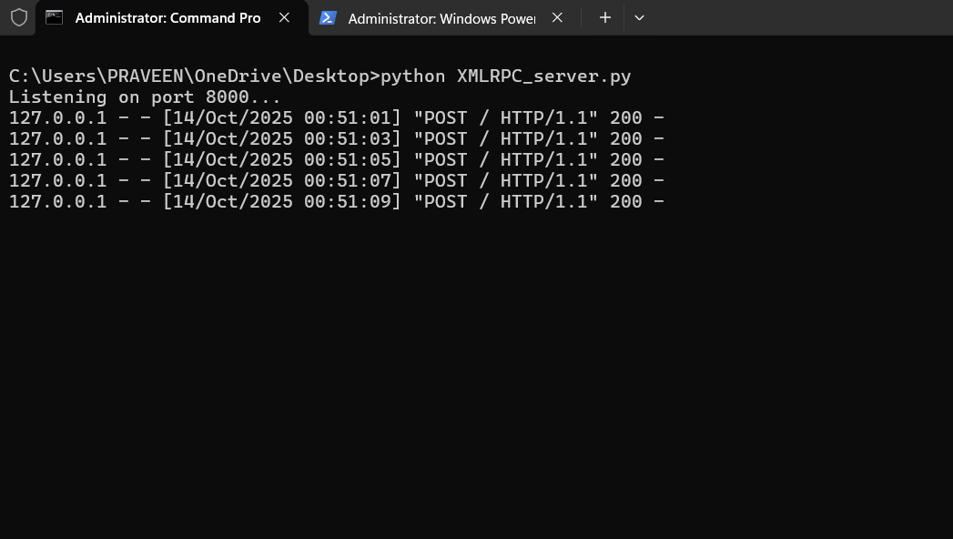
CLIENT:
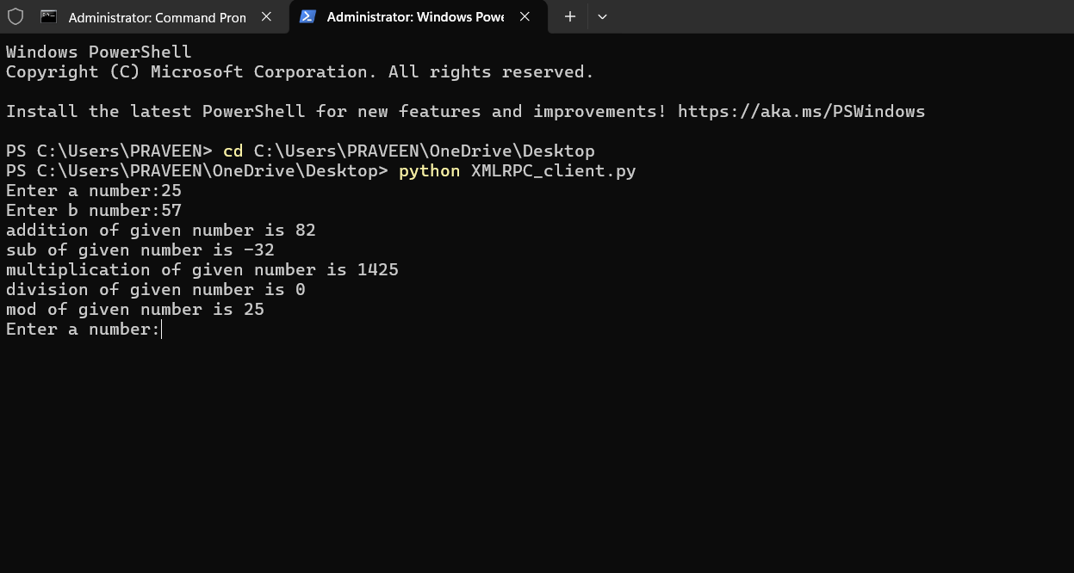
RESULT:
The XML-RPC calculator server successfully provided remote arithmetic functions. The client connected to the server and received correct results for addition, subtraction, multiplication, division, and modulo.

